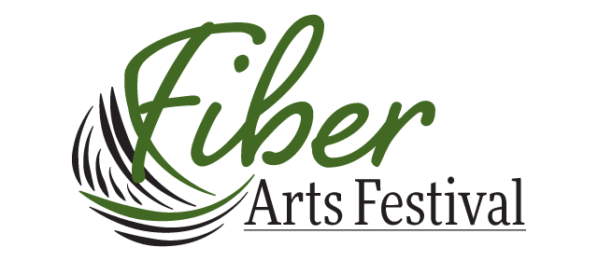
VENDOR REGISTRATION
August 3 & 4, 2024
Saturday 9 to 5 Sunday 10 to 3
Red River Valley Fairgrounds West Fargo, ND
Set-up time, 1 pm -7 pm Friday
7 am to 9 am Saturday

Business name__________________________________________________________________

ND tax license # (required) ___________________________ http://www.nd.gov/tax/faqs/topics/19/

Owner’s name____________________________________________________________________

Mailing address____________________________________________________________________

City______________________________________________ State________ Zip________________

e-mail______________________________________________________________________________
phone________-________-________________
WEBSITE URL_________________________________________________________________________
□ single booth $90 (10 by 10 feet) □ double booth $180
Important: Do you need electricity in your booth? □ yes (they must drop the cord before set-up time)
We will provide 2 tables per booth check here if you DO NOT want our tables □
□ check enclosed □ charge card, we will invoice you via Square
Mail this form with payment to email form as attachment to julie@oakestruckandtrailer.com
Fiber Arts Festival to
J. Mangnall, Treasurer
Print a copy for your files
11936 79th Ave SE
Stirum, ND 58069
701-742-3342
□ contact me about teaching a class □contact me about a raffle basket donation

